Entity-relationship Model

Database Relational Schema

Constraints and Computed Column

SQL Server Database

Database Queries

- Retrieve all records and all columns from a single table
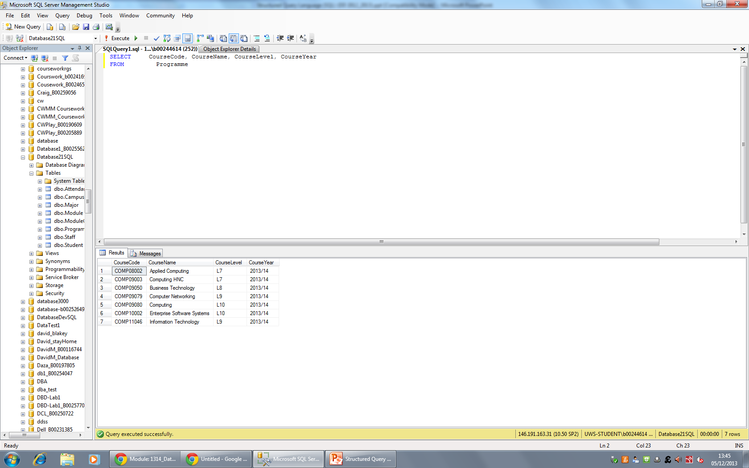
- Retrieve some records and only some columns from a single table.
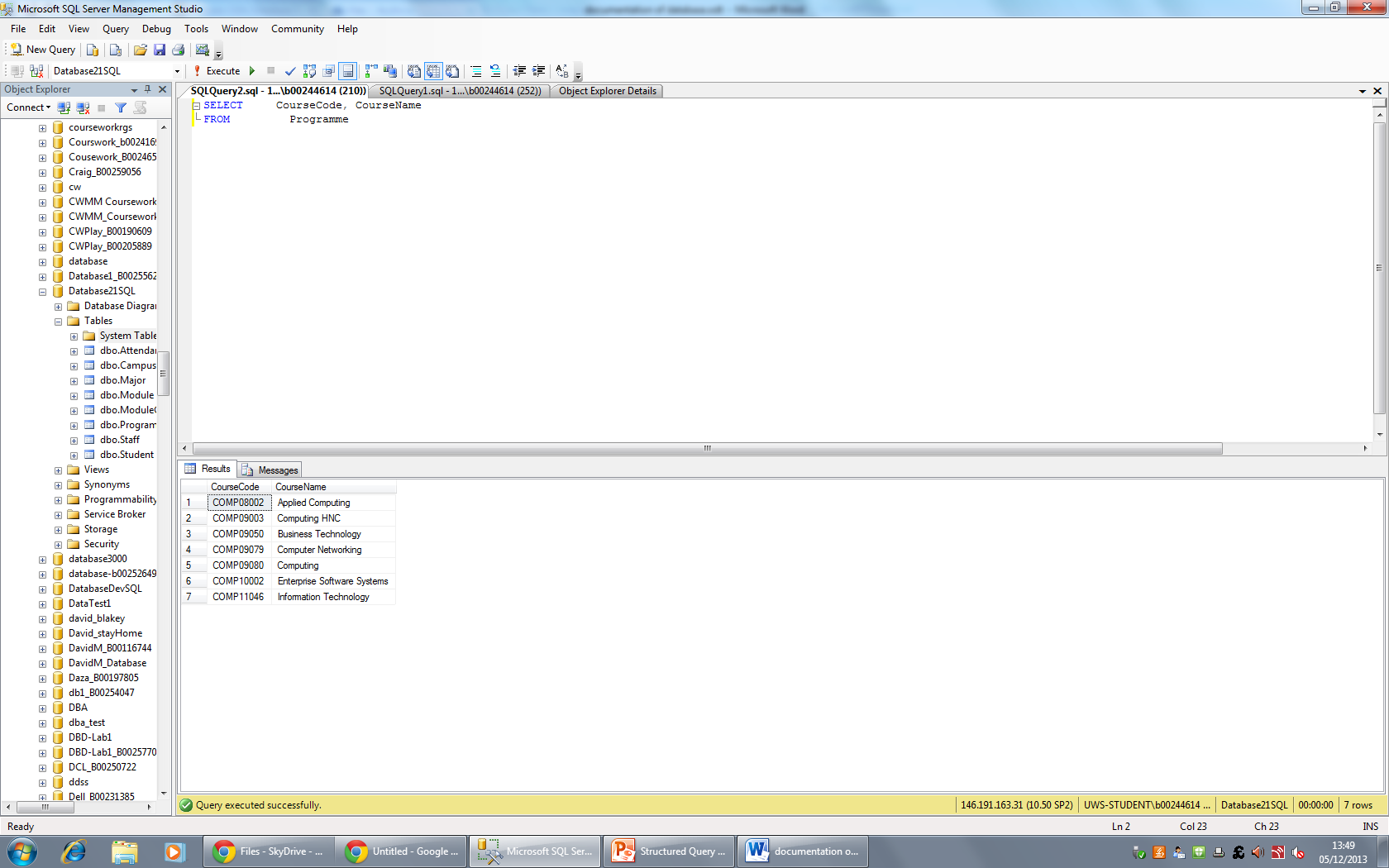
- Retrieve all related records and all columns from two related tables.
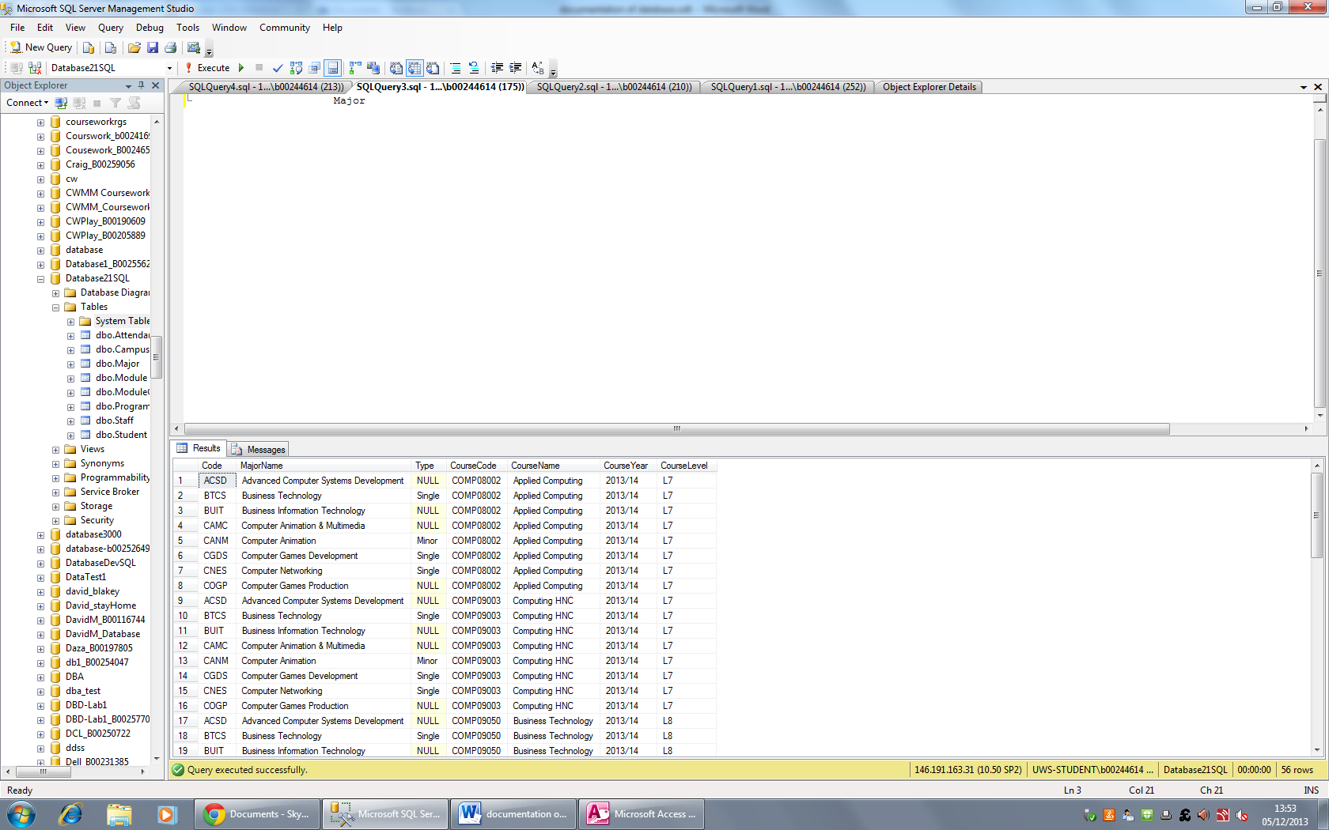
- Retrieve some related records and only some columns from two related tables.
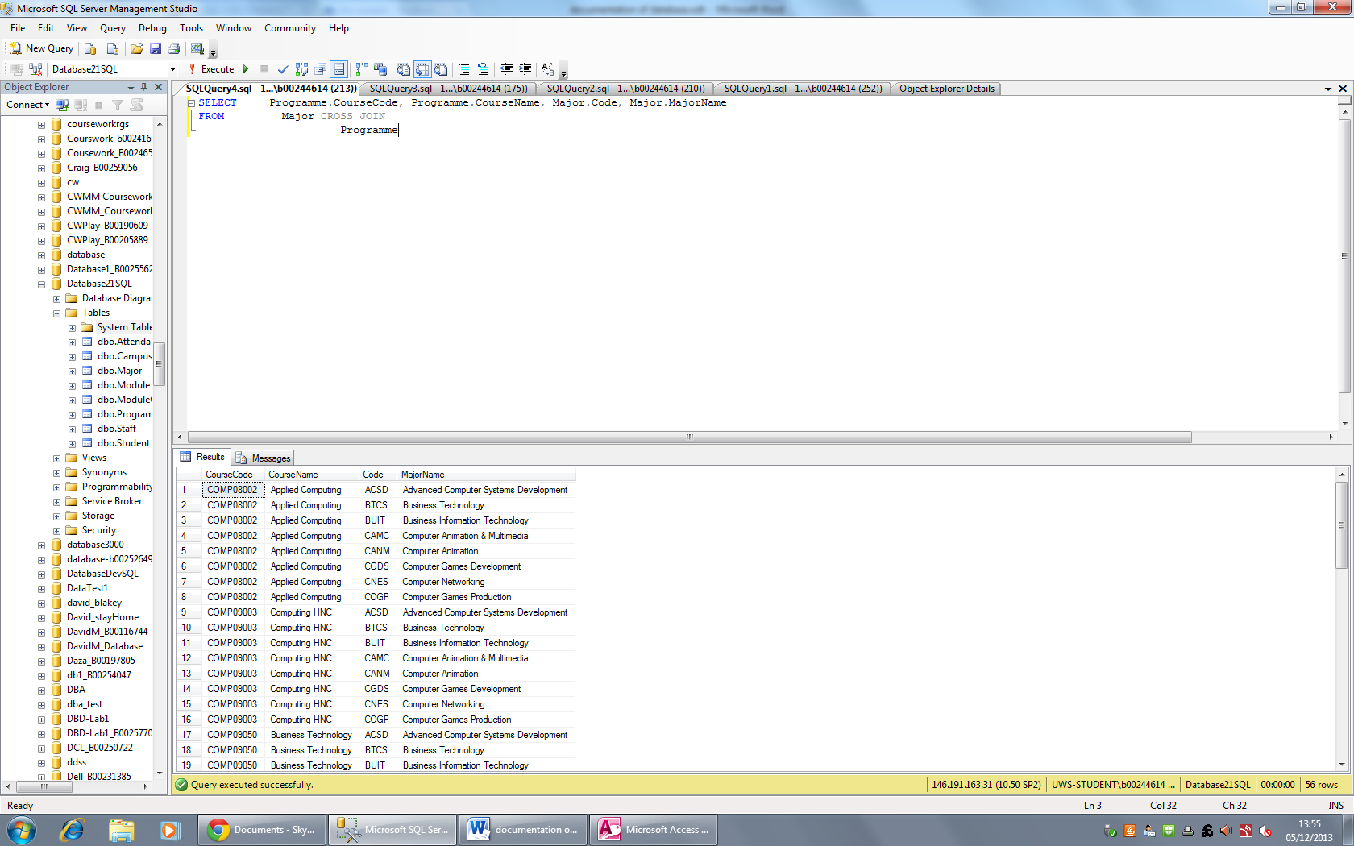
- Retrieve all related records and only some columns from three related tables.
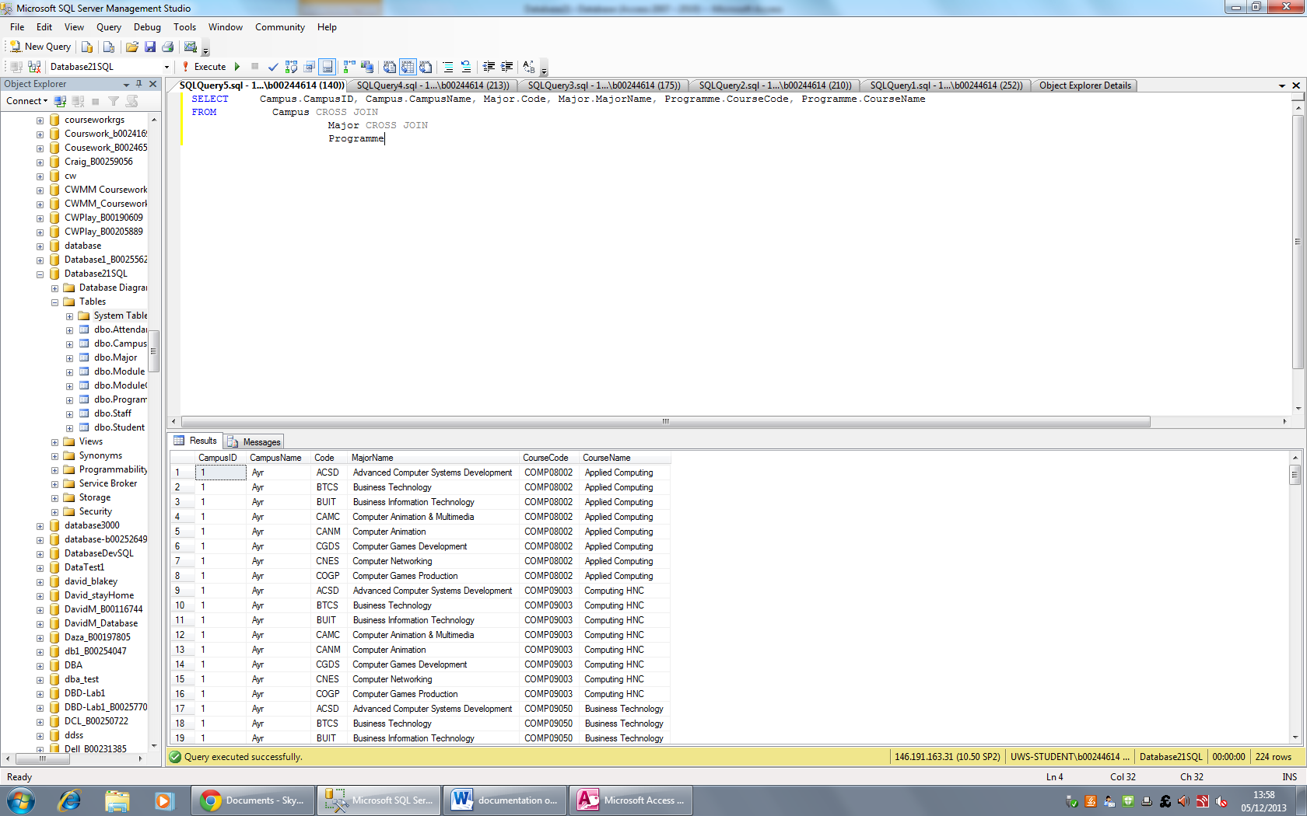

- Retrieve all records and all columns from a single table and include a single calculated column. Give the calculated column an appropriate name.
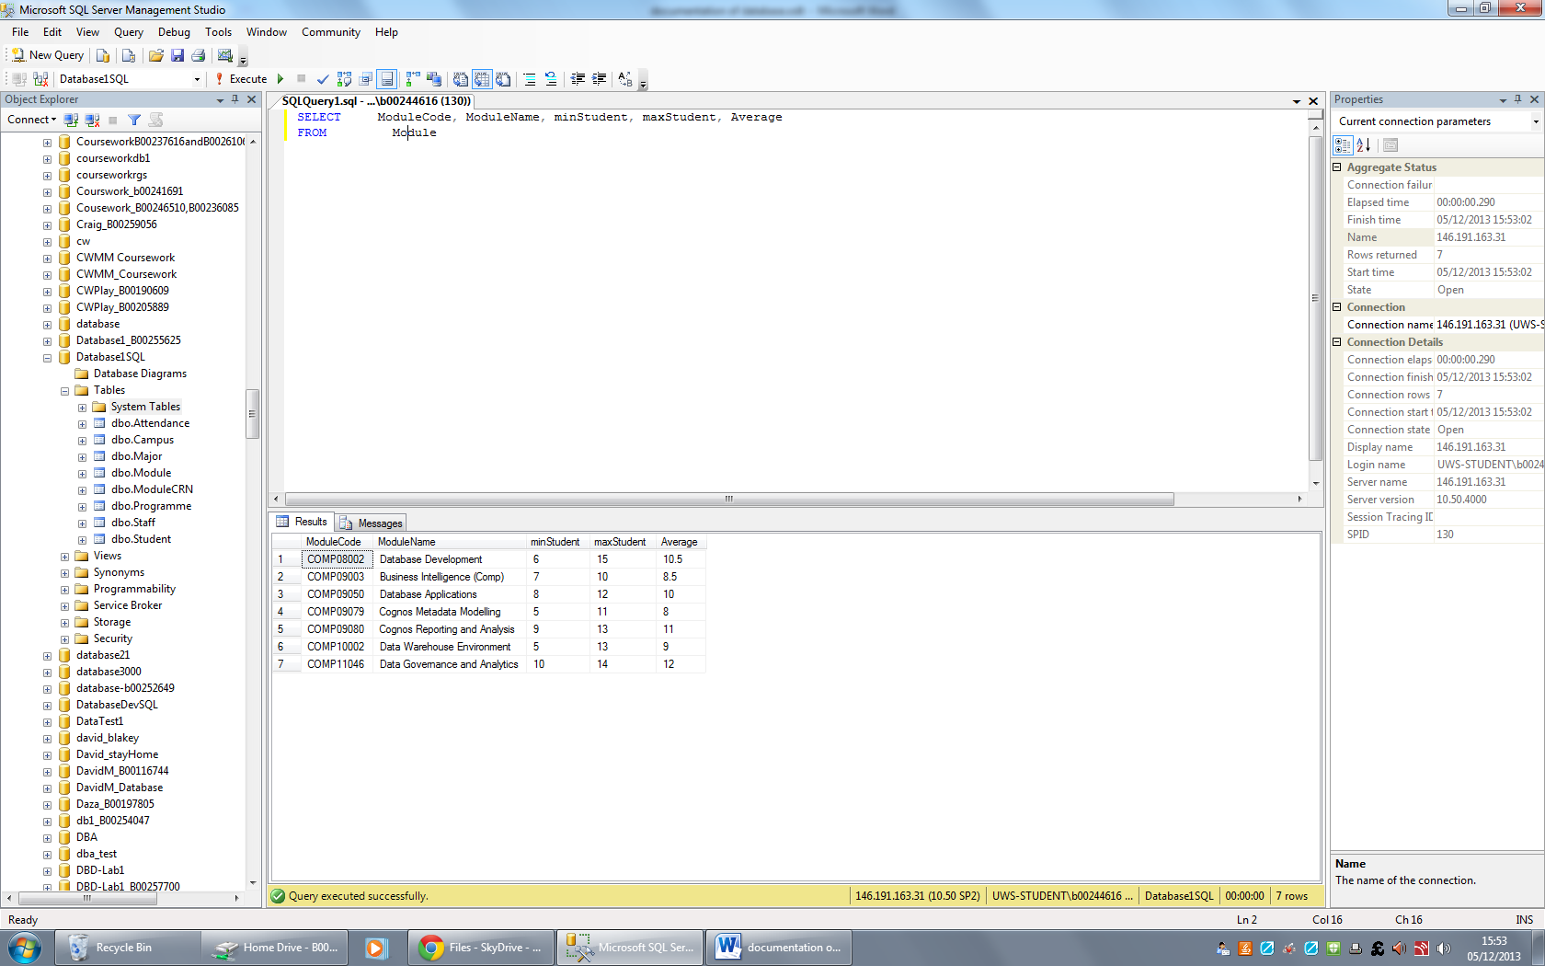
- Retrieve some records from a single table using pattern matching.
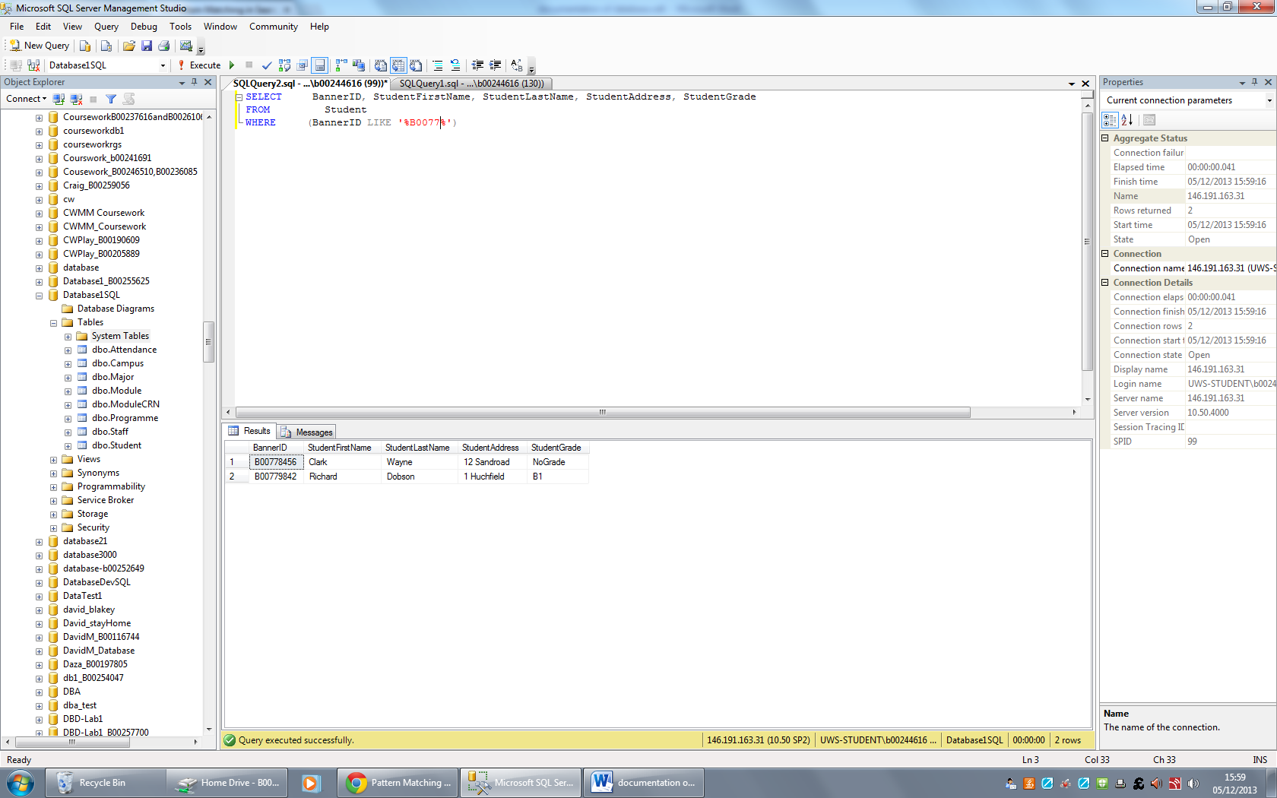
- Retrieve records from a single table that contain nulls in a column. Hint: use ‘is null’.
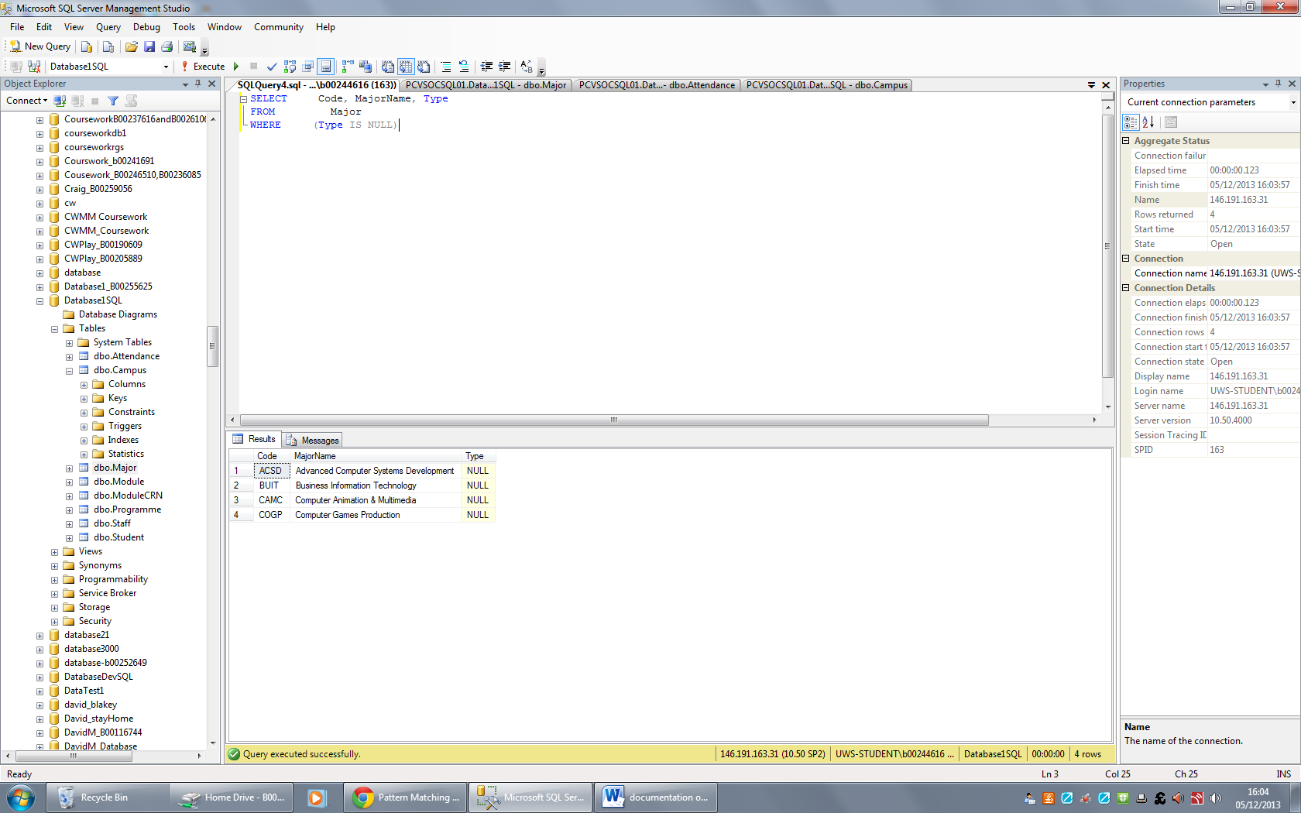
- Retrieve records from a single table that do not contain nulls in a column. Hint: use ‘is not null’.
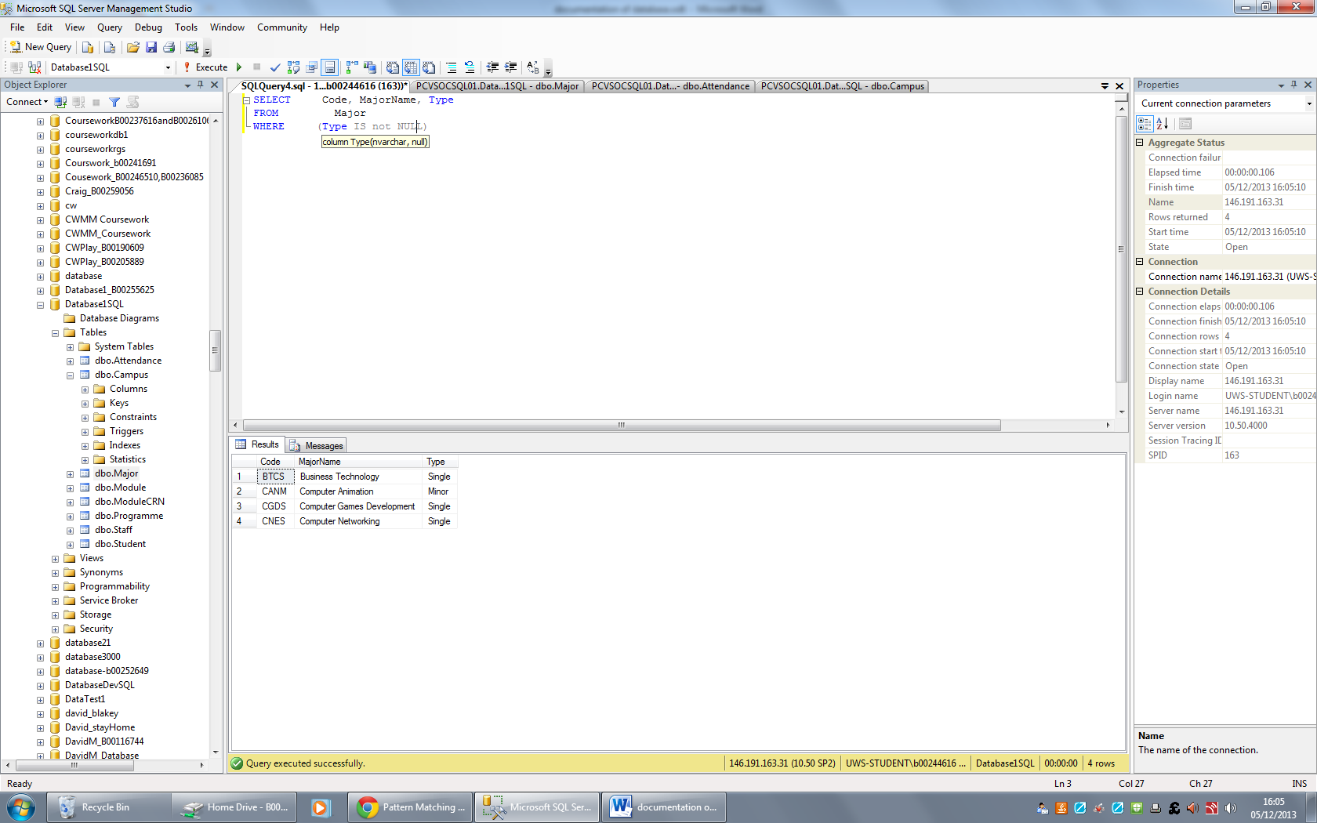
- Retrieve all records from a single table that are ordered using two non-primary key columns.
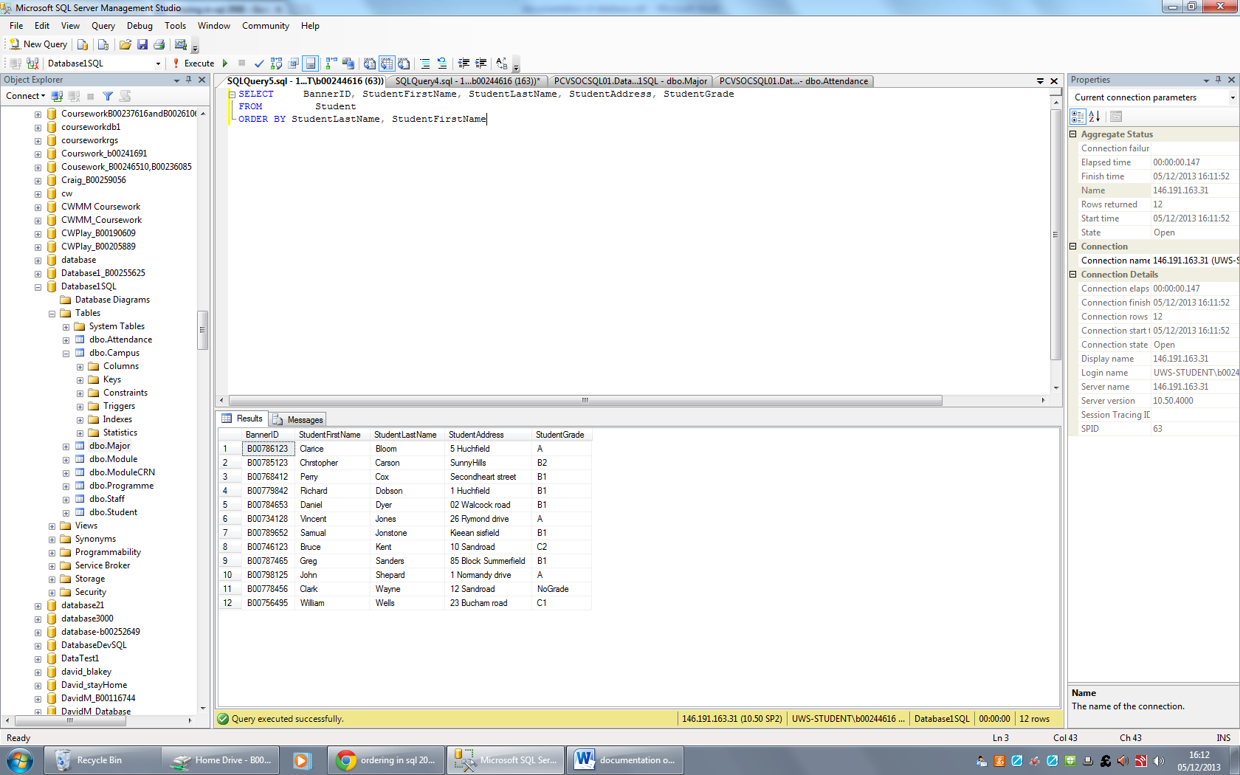
- Retrieve a single aggregate value (such as average or sum) for a single table.
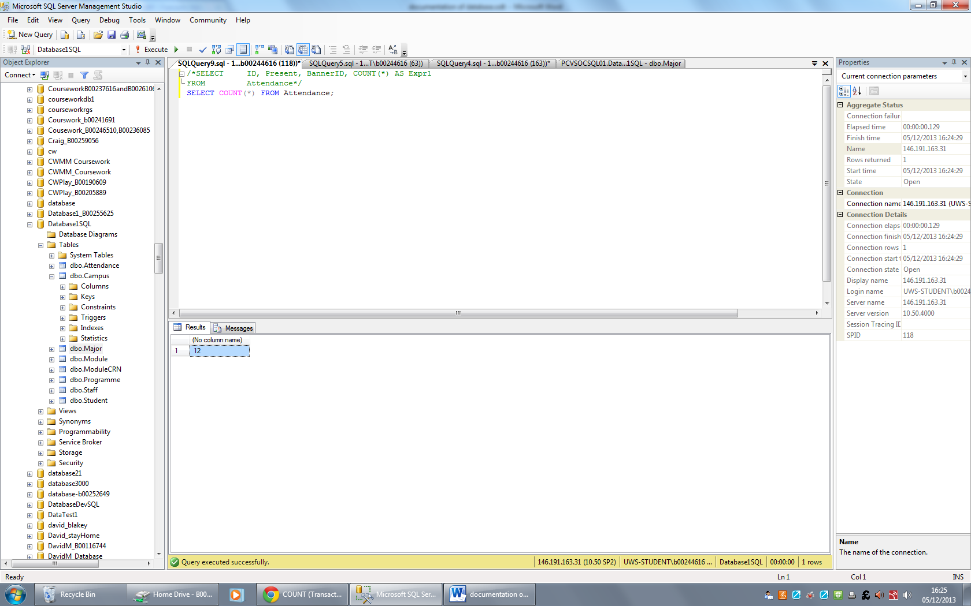
- Retrieve groups of records from a single table. Hint: use GROUP BY.
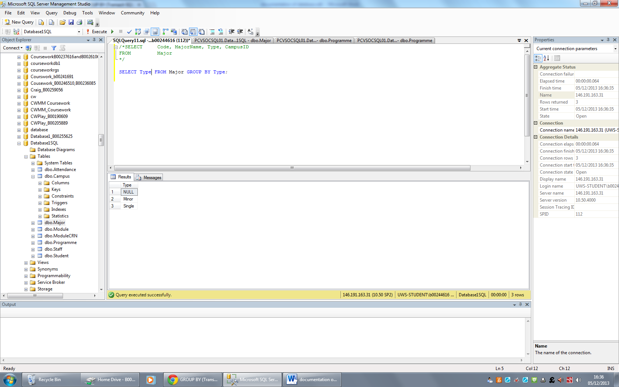
- Retrieve some groups of records from two related table. Hint: use GROUP BY and HAVING.
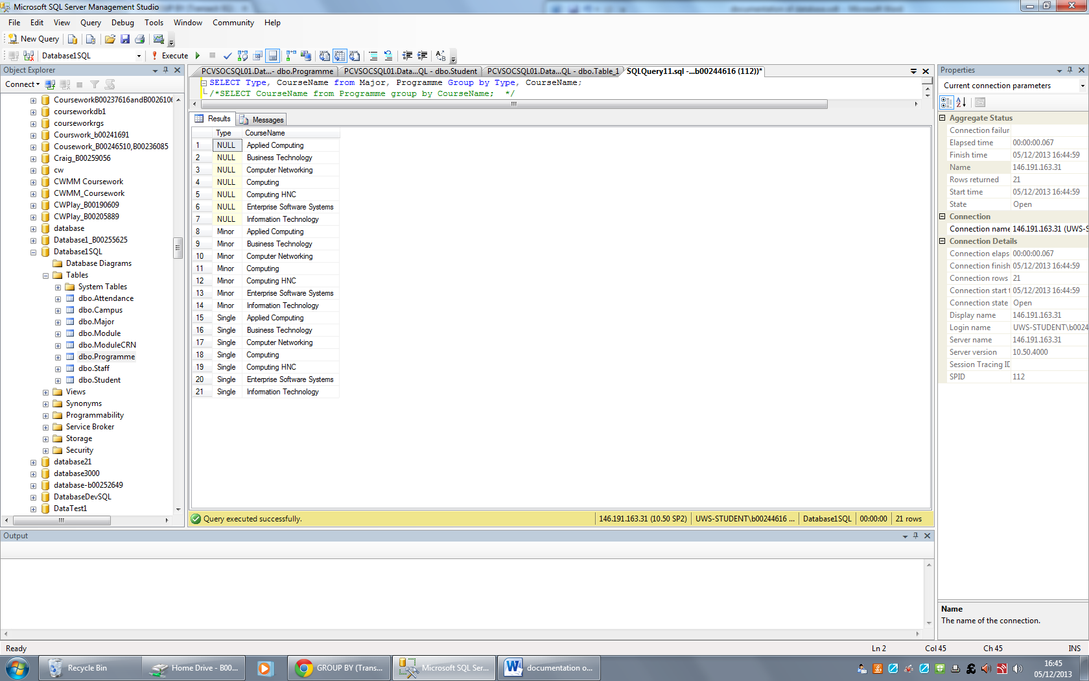
- Retrieve some records and some columns from a table based on the value(s) retrieved from another table. Hint: Use a nested table.
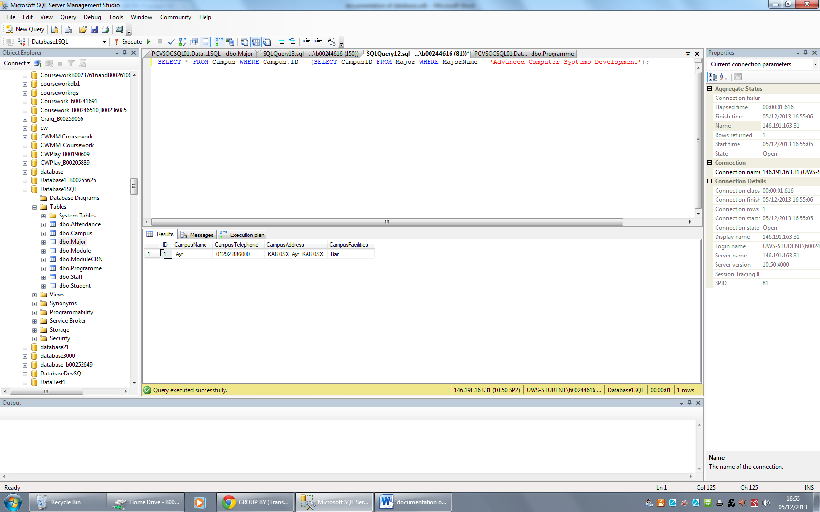
- Retrieve some records and some columns from a table based on the value(s) retrieved from another table, which are based on the value(s) from another table. Hint: Use two nested tables.
*
- Retrieve all records from one side of two related tables. Hint: Use LEFT OUTER or RIGHT OUTER join
*

- Retrieve all records from both sides of two related tables. Hint: Use full outer join.
*
- Retrieve all records from three related tables. HINT: Use full outer join.
*
- Provide any query you think is useful to demonstrate your knowledge.
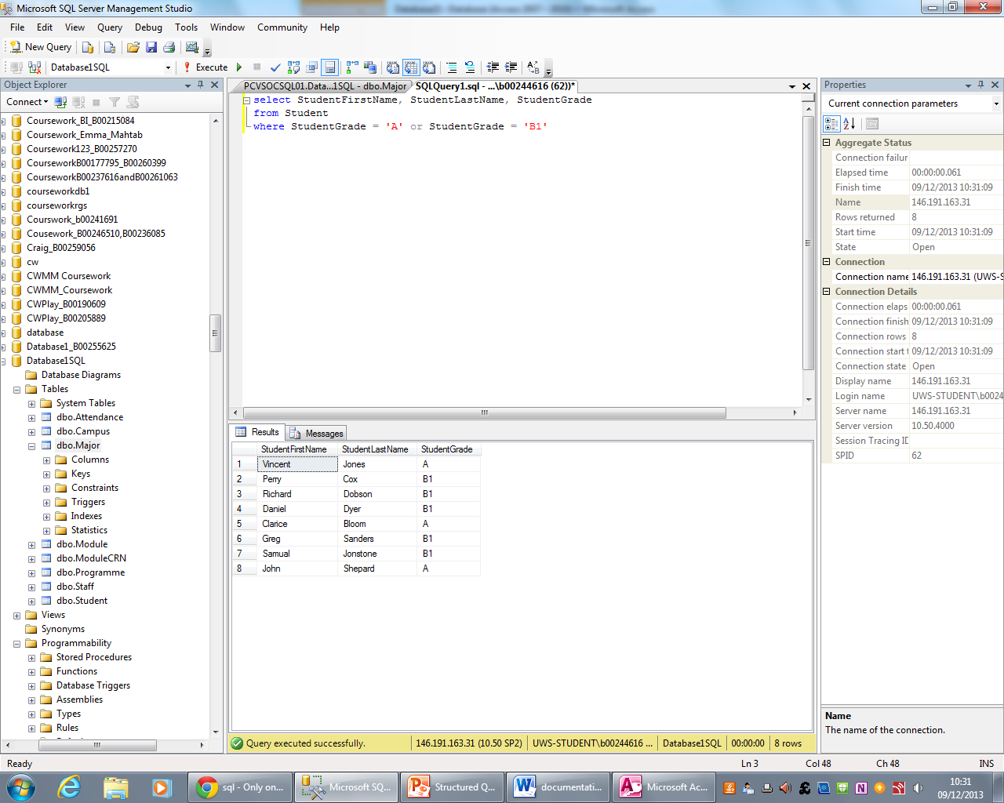
- Provide any query you think is useful to demonstrate your knowledge.
